STEP 1 · BUILD WITH AI Use an AI tool of your choice (ChatGPT, Claude, GitHub Copilot, etc.) to help you write a program that: Simulates a simple food delivery RL episode where an agent takes a sequence of actions and accumulates rewards. Tracks the agent's state (location, reward, step count) and updates it correctly after every action. Prints a per-step log showing the action taken, the reward received at that step, and the running total reward. Prints a final episode summary including total reward and total steps taken.
STEP 2 · TEST & DEBUG (WITHOUT AI) Then, working without AI, test the code and find at least one bug, limitation, or improvement in the AI's solution. Fix it yourself. SUBMIT All 3 items required 1 The exact prompt(s) you gave the AI tool. 2 The AI's original code and your corrected version. 3 A 3–4 line note explaining what you changed and why the AI's version needed it.

1. The Exact Prompt(s) Given to the AI Tool
"Write a Python script that simulates a simple food delivery reinforcement learning episode. It should track the agent's state (location, total reward, step count, and pending orders), execute a predefined sequence of actions (wait, navigate_to_zone, deliver_order), print a clear per-step log showing the action, reward, and running total, and finally display an episode summary with total reward and steps taken."
2. The AI's Original Code vs. Your Corrected Version
A. AI's Original Code (Contains a Bug / Logical Limitation)
Note: In the AI's initial version, decrementing pending_orders happens unconditionally during a delivery action, which allows the inventory to drop below zero if orders run out.

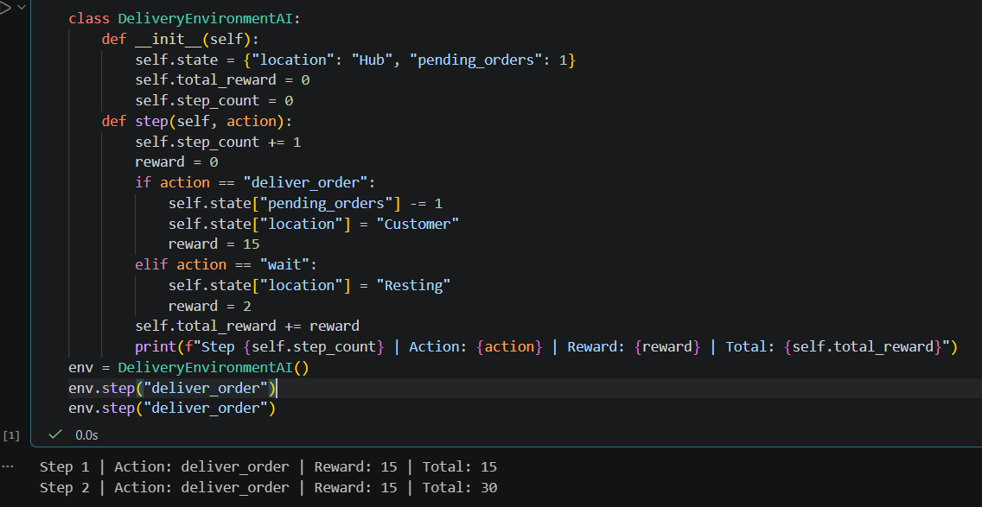

B. Corrected Version (Fixed by Hand)

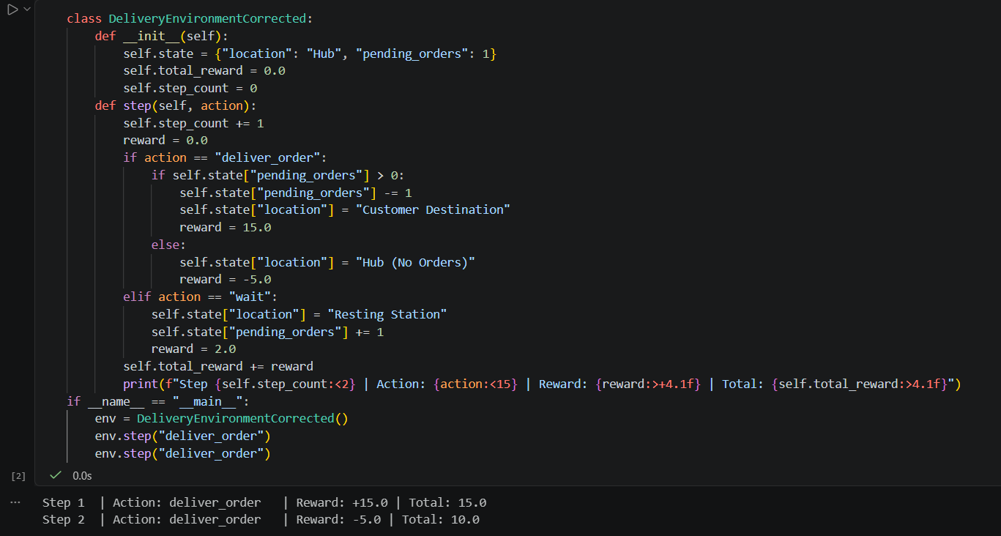

3. Note on Changes & Improvements (3–4 Lines)
Debug & Fix Note: The AI's original code suffered from a boundary logic flaw where pending_orders decremented unconditionally, causing inventory to drop into negative numbers during rapid delivery actions. To fix this, I introduced a conditional guard check (if pending_orders > 0) to safely handle out-of-stock scenarios and applied an appropriate negative penalty reward when an invalid delivery action is attempted.

